SMA Final Project Proposal
Jacob Ramey, Matthew Ozoroski, Raj Singh, James Barber, Alex Urbina, Myan Indugula*
*Equal Contributors

Project Idea
We are interested in understanding how well modern language models can capture human emotion in social media text. In this project, we will focus on Reddit posts, where users often describe personal experiences and feelings in a natural way. We build directly on the setup introduced in "Fluent but Unfeeling: The Emotional Blind Spots of Language Models" (Shu et al., 2025), which frames emotion prediction as a masked language modeling task. In this setting, the emotion word in each post is hidden, and the model must infer it from the surrounding context. While this sounds straightforward, it turns out to be a challenging problem because emotions are not always expressed directly, and similar situations can elicit different emotional responses.
Our group has six members, so each person will take one model from the comparison presented in the paper and evaluate it individually. This gives us a good spread across model families and sizes. In addition to reproducing the baseline results reported by Shu et al. (2025), we will fine-tune each model using LoRA to see whether task-specific adaptation improves performance.

Motivation
The main motivation for this project stems from the paper's findings, which show that even large models still struggle with fine-grained emotion recognition. Although performance improves as model size increases, the gains are not as large as one might expect. This suggests that simply scaling models is not enough to solve the problem fully.
Another reason this problem is interesting is its connection to real-world applications. Emotion understanding plays a role in areas like content moderation, mental health support systems, and general sentiment analysis. If a model misinterprets a user's emotional state, it could lead to poor or even harmful responses. For that reason, improving alignment between model predictions and actual human emotions is important.
Our approach is motivated by the idea that models may benefit more from targeted training than from additional scale. Instead of just using larger models, we want to see whether adapting them specifically for this task yields better results.

Dataset
We will use the EXPRESS data set introduced in the paper. This dataset is constructed from Reddit posts where users explicitly describe their emotions. The dataset is large, with over 30,000 posts, and includes a wide range of emotion labels, well beyond simple categories like positive or negative sentiment.
One of the main advantages of this dataset is that the emotion labels are self-disclosed by users rather than assigned by annotators. This makes the labels more realistic, though it also introduces some variability, since people may describe similar feelings with different words.
Each example in the dataset masks the emotion word in the text, and the model is asked to predict it. This setup allows us to evaluate how well the model understands the context leading to the emotion. For example:
Text: I feel <mask> after failing my exam even though I studied for weeks.
Label: disappointed
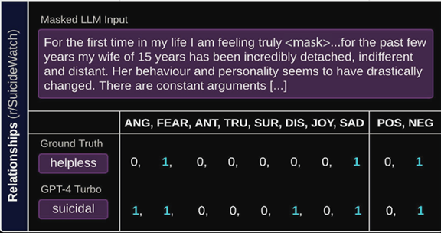Figure 1: Example of masked emotion prediction and model comparison (Shu et al., 2025).

Approach
We plan to build directly on the authors' codebase. This includes scripts for dataset handling, model inference, and evaluation. Using their framework ensures that our results are directly comparable to those reported in the paper.
Each group member will start by running a baseline experiment using their assigned model. This involves using either zero-shot or few-shot prompting to generate predictions. Once we have these baseline results, we will fine-tune the same models using LoRA.
LoRA allows us to adapt the model by modifying only a small number of parameters, which makes training more efficient. We will use LLaMA Factory to implement this, since it provides a simple interface for applying LoRA to different models.
After fine-tuning, we will run inference again and compare the results to the baseline. The main question we are trying to answer is whether this additional training step improves the model’s ability to capture emotion.

Multiple Approaches
We will evaluate two main approaches in this project. The first follows the baseline setup from the paper, using zero-shot and few-shot prompting. The second applies LoRA fine-tuning to adapt each model to the task. Comparing these approaches will help us determine whether task-specific adaptation improves performance over prompting alone.
Since our group has six members, each person will use a different model and explore slight variations in setup (such as LoRA configuration or prompting strategy), resulting in multiple distinct experimental approaches across the group. The models from the original paper are shown in Table 1.

Metrics
We will use the same evaluation metrics as the paper so that our results are consistent and comparable. These include lexical accuracy, vector accuracy, and F1 score.
Lexical accuracy measures exact matches between predicted and true emotion labels, which is useful but somewhat strict. Vector accuracy is more flexible, as it compares emotions based on underlying dimensions such as joy, fear, and sadness. This is important because two different words can still represent similar emotions. The F1 score helps capture partial correctness and provides a more balanced view of performance.
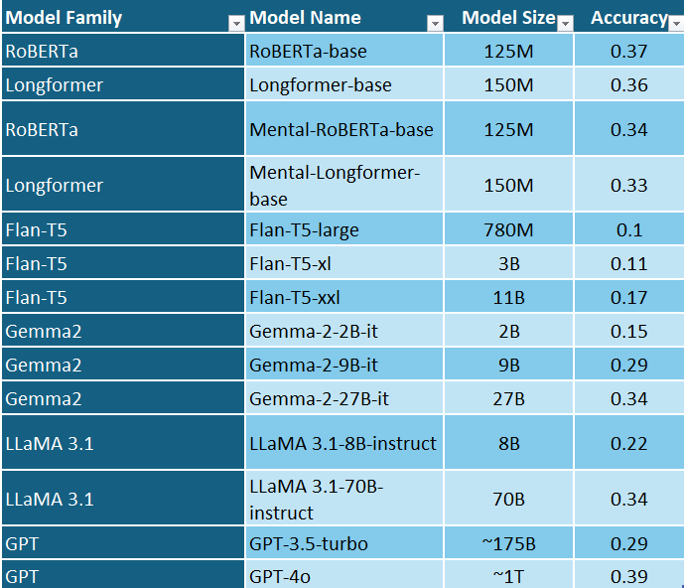Table 1: Model size vs emotion detection accuracy across model families (Shu et al., 2025).

References
Hu, E., Shen, Y., Wallis, P., Allen-Zhu, Z., Li, Y., Wang, L., & Chen, W. (2021). LoRA: Low-Rank Adaptation of Large Language Models. Retrieved from https://arxiv.org/abs/2106.09685
Shu, B., Joshi, I., Karnaze, M., Pham, A., Kakkar, I., Kothe, S., . . . ElSherief, M. (2025). Fluent but Unfeeling: The Emotional Blind Spots of Language Models. Retrieved from https://arxiv.org/abs/2509.09593

